Integrated Three-Phase Power Flow and Multi-Energy Demand Response on an IEEE 37-Bus Feeder

Abstract
This paper is an extended analysis of unbalanced three-phase power flow, multi-energy hub modelling and customer-level integrated demand response (IDR) on a modified IEEE 37-bus distribution feeder. To begin with, a three-phase GaussSeidel power-flow model is solved to completion and with comparisons to a linearized DistFlow (LinDistFlow) approximation with the exact impedance and load data available on the IEEE37News spreadsheet. The comparison is the quantification of the accuracy of linear models typically employed in the convex formulations of optimal power flow (OPF) on radial networks. Second, a representation of a local multi-energy hub that is border equivalent is obtained, combining the internal action of a combined heat and power (CHP) unit, gas boiler, and thermal storage into a practical area as well as a unified bidding curve of the active distribution network. Lastly, a 24-hour IDR-OPF problem is devised on a single flexible customer relating to the final bus of the feeder. The optimisation co-ordinates electric, heat and gas demand when there is time of use tariffs as well as punishing three phase voltage unbalance and imposing network limitations. The results show that the linearized DistFlow model reproduces the full three-phase voltages with root-mean-square errors of about 1.1%, that the energy hub offers a convex and economically meaningful cost curve at the grid border, and that IDR significantly reshapes the customer’s load profile while maintaining the voltage unbalance index below 1.3×10⁻³ p.u.
Keywords— three-phase power flow, linear DistFlow, multi-energy hub, integrated demand response, voltage unbalance, IEEE-37 test feeder, optimal power flow.

1. Introduction
High penetration of distributed generation, electrified heating and transport and flexible responsive loads are putting an increased strain on distribution networks. These cause phase imbalance as well as voltage fluctuations especially in low-voltage feeders and medium-voltage radial feeders [2] [5]. Demand-side control strategies and to determine the operating limits therefore require accurate three-phase power-flow models. Meanwhile, tools based on optimisation like OPF are usually based on linear or convexified power-flow models to obtain manageable scheduling and planning [6] [7]. It is thus necessary to understand the error between nonlinear three-phase AC power flow and linearized DistFlow models on realistic feeders.
Simultaneous with these network-based issues, so-called multi-energy systems have rapidly expanded, where the flow of electricity, natural gas and heat are designed to interact in an integrated way [9]. Energy-hub concept offers a convenient modelling framework, where local assembly of CHP units, boilers, heat pumps and thermal storage is modelled in the form of a single node linking to the electrical and gas grid [1][10]. To operate at distribution level markets and in active distribution network (ADN) it is convenient to substitute the internal hub model by a border equivalent feasible region and bidding curve between net electrical exchange and thermal service and operating cost.
Demand response (DR) is increasingly also viewed as one of the relatively inexpensive approaches to enhancing system flexibility and supporting renewable generation. Time-of-use (TOU) tariffs and DR programs based on optimisation have received a lot of research in the case of electricity only and multi-energy systems [4][8]. The effects on three-phase voltages and unbalance have to be explicitly considered when applying DR to the end of long radial feeders, however, as the poor phase balancing may exacerbate losses and poor power quality [2][5].
It is against this backdrop that the current research paper will add to the existing literature through a logical three-part computation scheme building on an adapted version of IEEE 37-bus feeder. Task 1 is a measure of the error between the flow of three phase AC power and a Wang-style linearized DistFlow model based on the actual impedance and load matrices. Task 2 uses a border-equivalent model on a local multi-energy hub connected to the ADN, in order to compute its viable operation space and aggregate bidding behaviour. Task 3 creates an IDR-OPF of a single flexible customer with a connection at the tail of the feeder, and coordinates the demand in 24 hours of electric and heat and gas under TOU tariffs as well as implements voltage limits and punishes three phase unbalance.

2. Methodology

2.1 Three-Phase AC Power Flow and Linearized DistFlow (Task 1)
The initial set is the IEEE37 news dataset, which comprises of the connectivity, three phase line impedances and per-branch phase-specific loads of a 32 node unbalanced radial feeders based on the original IEEE 37-node test system, a standard by which distribution-system algorithms are evaluated [7]. A special form parsing the spreadsheet builds up arrays of originating and destination bus of the spreadsheet along with the 3 3 complex impedance matrices of self and mutual coupling of phases on the different branches.
The 3N Nodal admittance matrix Y 3 N is constructed by summing the contribution of each branch into the correct positions in the block. Self admits and mutual admits are added up to complete inter-phase coupling. Initial active and reactive loads expressed in kilowatts and kilovolt-ampere reactive are added at every to bus and transformed to per unit on a 10 MVA, 12.66 kV base and traced to their corresponding phase nodes.
A GaussSeidel iterative solver of three phase networks is used to obtain the exact AC power-flow solution and this solver iterates phase-A,phase-B and phase-C bus voltages until power-balance residuals drop below this tolerance with bus 1 considered the slack node of magnitude 1.0 p.u. The standard method of unbalanced radial analysis of distribution, when using GaussSeidel and similar methods, is still in use in industry and research [3].
Simultaneously, a linearised DistFlow model is developed in accordance with the generalised LinDistFlow scheme of radial networks [6]. The approach estimates voltage differences to be affine functions of net active and reactive injections, based on sensitivity matrices based on the admittance matrix and line parameters. Currently, a tuning parameter of λ=0.15 is used to combine P V and Q V sensitivities according to Wang-type formulae. The resultant linear system gives approximate voltages of the phase at the same loading pattern.
To quantify the approximation error, the phase-specific per-bus magnitudes from AC power flow, $V_{ϕ}^{AC}\left(i\right)$, are compared with the linearized values $V_{ϕ}^{LPF}\left(i\right).$ For each phase ϕ\phiϕ, the maximum absolute error and the root-mean-square error (RMSE) across all buses are computed. These metrics are summarised later in Table 1. The voltage magnitude profiles from both methods are plotted against bus index, giving the overlaid curves shown in Figure 1.

2.2 Border-Equivalent Multi-Energy Hub Modelling (Task 2)
Task 2 is a compactification of a local multi-energy hub with a connection to the ADN to a border-equivalent model. The facility has a gas-powered CHP, a standard gas boiler, a thermal storage system and a connection to the upstream electricity system. The given energy-hub architecture is typical of microgrids on campuses and district-heating systems and provides an effective tool to combine electricity and gas infrastructures of utilisation [9][10].
One hour of representation is taken into account. The decision variables are established as net electric power exported to the ADN Pel,export, electric power bought in the upstream grid, gas to CHP and boiler, and the discharge of the thermal storage. The choices of device efficiencies and capacity limit are dependent on normal CHP and boiler operation. The modelling imposes an electric power balance between export, local demand, CHP generation and purchases alongside a thermal balance that maintains a constant heat demand that is satisfied by CHP heat, boiler heat and the discharge of the storage.
These relationships are given as linear equality and inequality constraints and result in a polyhedral feasible set in the decision-variable space. In order to compute the border-equivalent representation, a vertex-search algorithm is implemented based on a sequence of linear programs with directions of objectives bouncing over the variable space. The linear programs optimise a specified directional vector and the extreme points are projected onto the two-dimensional plane that is defined by Pel,export and total thermal output. The unique vertices form the boundary of the feasible region of the hub as viewed through the ADN interface after the duplicates have been eliminated.
The operating cost of the hub is expressed by the amount of electricity upstream purchases, gas, CHP and boiler usage and a minor cycling cost of thermal storage, with the realistic energy prices on the basis of present European retail and wholesale cost ratios [4]. At a grid of candidate levels of exports (between -1MW (import) and +2.5MW (export)) a second family of linear programs minimises the operating cost subject to all device and balance constraints given Pel,export fixed. The ensuing mapping of net electric exchange and minimum operating cost gives the aggregate bidding curve of the hub which may be provided to the ADN operator in a local flexibility market [1]. The feasible region and bidding curve is shown in Figure 2.

2.3 Integrated Demand Response Optimal Power Flow (Task 3)
Task 3 expands the analysis to a complete 24-hour IDR-OPF problem of a single flexible customer that is linked to the last bus of the IEEE 37-bus feeder. It will work to co-optimise the active power in hourly electric, heat and gas loads in response to TOU tariffs and observe network constraints and reduce three-phase voltage unbalance. Multi-vector system Simpler network models have been studied as the basis of multi-vector energy system similar integrated DR formulations [4][8].
The horizon is also discretized with 24 hourly intervals. Electricity, heat and gas tariffs are based on a representative TOU structure whereby low prices are charged at night and early morning time, intermediate prices are charged during the day and high prices are charged during the evening peak. The customer must take constant daily loads of 30 kWh of electricity, 40 kWh of heat and 20 kWh of gas throughout the day which are constrained by hourly peak powers that simulate realistic appliance and heating loads. These energy demands on daily basis are put as equality constraints, and the daily per-hour limits are put as inequality constraints on the decision vector.
In order to determine three-phase unbalance, the demand of the flexible customer is not evenly distributed across the phases. The distribution of electric power is 60 per cent on phase A, 30 per cent on phase B and 10 per cent on phase C, which represents typical single phase appliance distributions. The heat demand is centralized around the phase B which is heat pump or electric boiler whereas the heat-related gas consumption (such as CHP auxiliaries or cooking) is centralized around the phase C. This asymmetry achieves an unbalanced loading pattern at the terminal bus which is unrealistic.
The objective function represents the sum of the daily cost of energy and a penalty on voltage unbalance. The helper function apply_customer_load is applied to each hour and candidate schedule and optimally superimposes the phase-weighted incremental demand on the base per-unit phase loads of the entire feeder and solves a complete three-phase AC power flow with the same GaussSeidel solver as used in Task 1. Based on the resulting phase voltages at the customer bus, an index of a voltage unbalance is calculated as the largest relative difference between phase magnitudes and their mean as typically done in current definitions of power-quality assessment in distribution networks [2]. The square of the unbalance index is summed up of all hours and then multiplied with a weighting factor in such a way that excessive unbalance is punishable in comparison to the cost of energy.
Non-linear inequality constraints impose severe voltage magnitude limits of 0.95 to 1.05 p.u. on each phase at the customer bus per hour, and this corresponds to the conventional distribution code limits [2]. This produces a non-linear constrained optimisation problem which is solved with the sequential quadratic programming form of fmincon, with an initial flat schedule (i.e. every type of energy is equally used during the day). The optimisation is converging regularly within few iterations and this means that the problem is well conditioned.

3. Results

3.1 Comparison of Three-Phase AC Power Flow and Linearized DistFlow
Table 1 summarises the ranges of per-phase voltage magnitudes, obtained due to the three-phase AC power flow as well as the error values between AC and linearised DistFlow voltages. Voltages have been kept at 0.971 to 1.0 p.u. between phases, the greatest drop in all phases is near the feeders tail, which is in line with highly loaded rural feeders.
Table 1. Per-phase voltage range and LPF error metrics (Task 1).
Phase | AC voltage range (p.u.) | Max | RMSE
A | 0.9730–1.0000 | 0.019801 | 0.011160
B | 0.9711–1.0000 | 0.019715 | 0.010938
C | 0.9712–1.0000 | 0.019913 | 0.011032
The linearized version of the DistFlow model recreates the precise AC voltages with RMSE of approximately 0.011 p.u of all phases, and absolute worst case error of slightly less than 0.02 p.u. This accuracy is in line with the accuracy of generalized LinDistFlow formulations on radial networks found in the literature [6] [7].
Figure 1 shows the profile of phase-A, phase-B and phase-C voltage in the feeder, at the AC and LPF model. The solid curves are associated with the solution of the three-phase AC and the dashed curves with square markers are associated with the linearized approximation. The linear model effectively represents the overall trend, and the typical voltage rise about intermediate laterals, but underestimates voltages systematically about the middle part of the feeder, where line resistances and mutual couplings form non-linear interactions. The quantitative errors of Table 1 are consistent with the visual comparison of Figure 1.
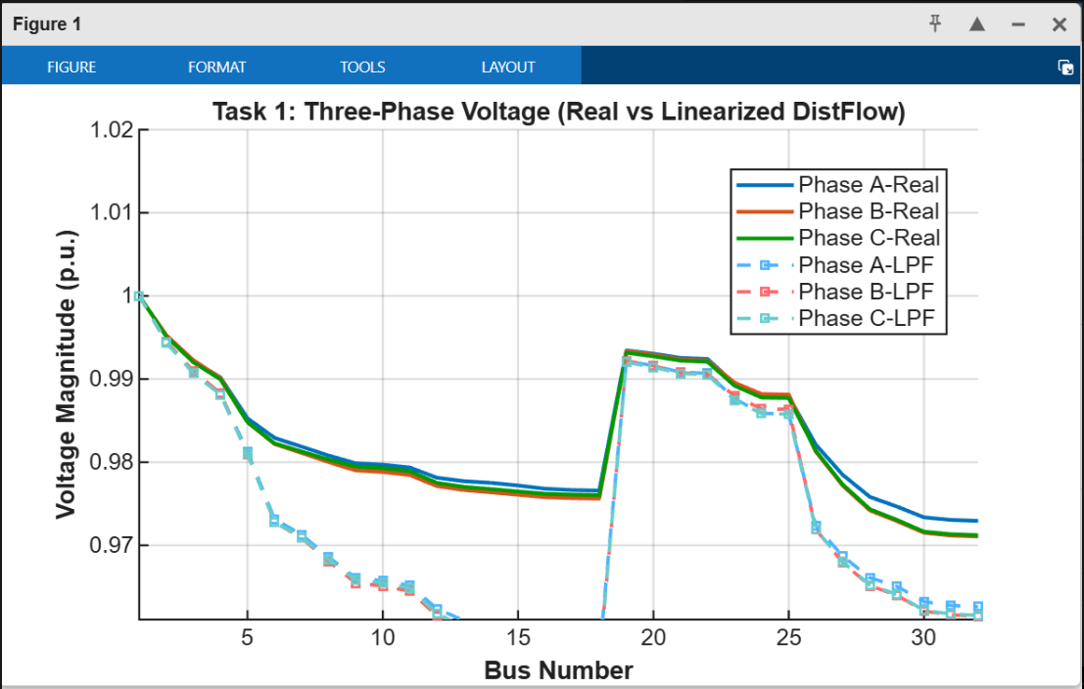
Figure 1. Comparison of three-phase AC power flow and linearized DistFlow voltage magnitudes along the IEEE 37-bus feeder.
In general, as Task 1 reveals, the linear model is sufficiently accurate as a surrogate of high-level optimisation, but it encourages the use of full three-phase AC power flow when precise unbalance and power-quality indicators are needed.

3.2 Multi-Energy Hub Feasible Region and Bidding Curve
The vertex-search algorithm of the multi-energy hub determines five different functioning vertices in the projected plane of net electrical exchange and thermal output. The hub should meet a constant 3 MW thermal load in all possible modes but there are vertices that generate excess heat as a result of CHP output. Table 2 indicates characteristic vertices, and related cumulative thermal output. Rounding of values is used to highlight the qualitative interpretation of values.

Table 2. Representative vertices of the multi-energy hub feasible region (Task 2).
Vertex | P_{el,export} (MW) | Q_{th} supplied (MW) | Interpretation
V1 | –1.0 | 3.0 | Import electricity, cover heat mainly via boiler
V2 | 0.0 | 3.0 | Self-sufficient in electricity, boiler dominant
V3 | 1.0 | 3.0 | Moderate export with balanced CHP and boiler
V4 | 1.0 | ≈4.6 | High-output CHP mode with surplus heat
V5 | 2.5 | 3.0 | Maximum export limited by CHP electric capacity
These vertices are plotted in the left side of Figure 2 and it can be seen that the hub can adjust its net electrical exchange between -1 MW and +2.5 MW and still fulfill its heat demand at any rate. The extra vertex at about 1 MW export and 4.6 MW thermal output is a point at which the CHP is operating at the thermal limit and the boiler is undercut, and thus, it has a high electric output and a high thermal output simultaneously. This node represents the end of the feasibility boundary and shows that the hub can provide large upward electric flexibility in case the ADN is not averse to accept excess heat, say through storage or district heating demand [9].
Figure 2, right panel, shows the aggregate bidding curve which is a curve that indicates the net electrical export in terms of the minimum operating cost. The curve is necessarily increasing: working at or slightly importing conditions provides the costs at about 45-60 per hour, but exporting 2.5 MW is almost three times as expensive at nearly 300 per hour. This rise is an indication of the fact that more gas has to be burned in the CHP and boiler to accommodate the export of electricity as well as the thermal service even as the income of the sale of electricity at the ADN boundary.
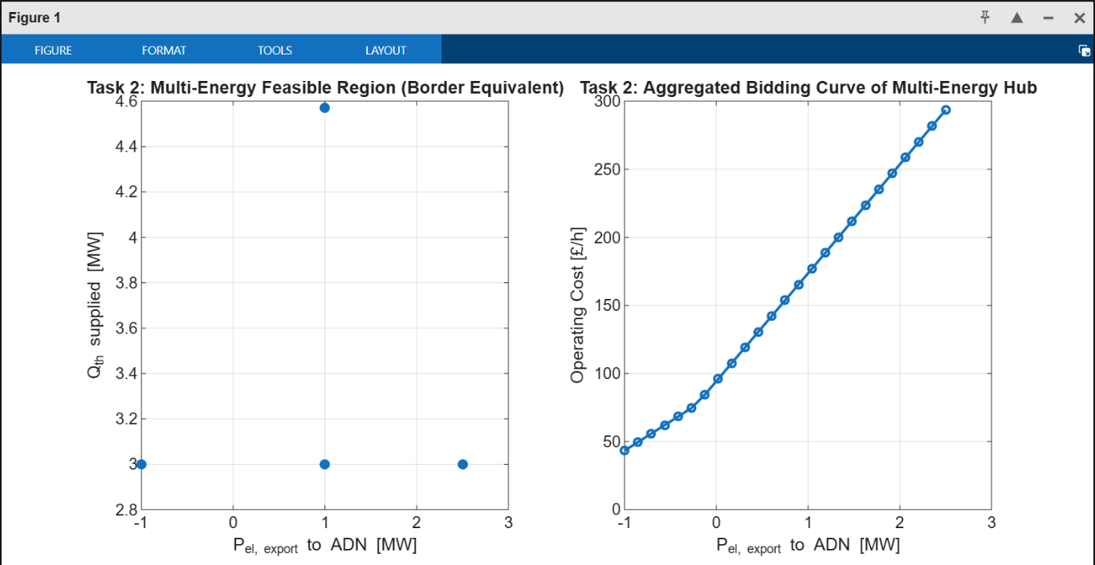
Figure 2. Task 2 results: (a) feasible region of the multi-energy hub in terms of net electrical export and thermal output; (b) aggregated bidding curve showing minimum operating cost as a function of net electrical export.
These findings indicate that the border-equivalent model gives a concise yet informative account of the techno-economic behaviour of the hub, which can be used in the distribution level market coordination and ADN scheduling algorithms [1].

3.3 Integrated Demand Response with Three-Phase Unbalance Consideration
The IDR-OPF in Task 3 converges within six sequential quadratic programming iterations, yielding an optimal objective value of approximately 6.58×10⁻³ in per-unit cost terms, with constraint violations below 2×10⁻¹⁵ and first-order optimality around 10⁻⁶. This indicates that the combined cost and unbalance penalty has been minimised to numerical precision subject to the power-flow and voltage constraints.
Figure 3 indicates the optimal resultant 24-hour electric, heat and gas demand (in kilowatts). The three energy streams are scheduled to operate near the full power limits during the low-price hours between 1:00 and 7:00. This is economically intuitive: the act of shifting consumption to the least expensive hours will meet a significant percentage of the daily energy need at a very low cost as per DR studies of TOU tariffs [4]. In the period between 8:00 and 17:00 when tariffs are adjusted to an intermediate level, the flexible loads are reduced to low constant values that merely sustain the minimum service as well as creating a smoothing process of voltage profiles. Throughout the evening peak 18:00-22:00, the optimisation drives all flexible loads close to zero taking advantage of the fact that the daily energy limits have already been met by far. Lastly, the hours during 23:00 and 24:00 satisfy the residual energy demands with a short-lived rise in the three loads after the tariffs revert to off-peak.
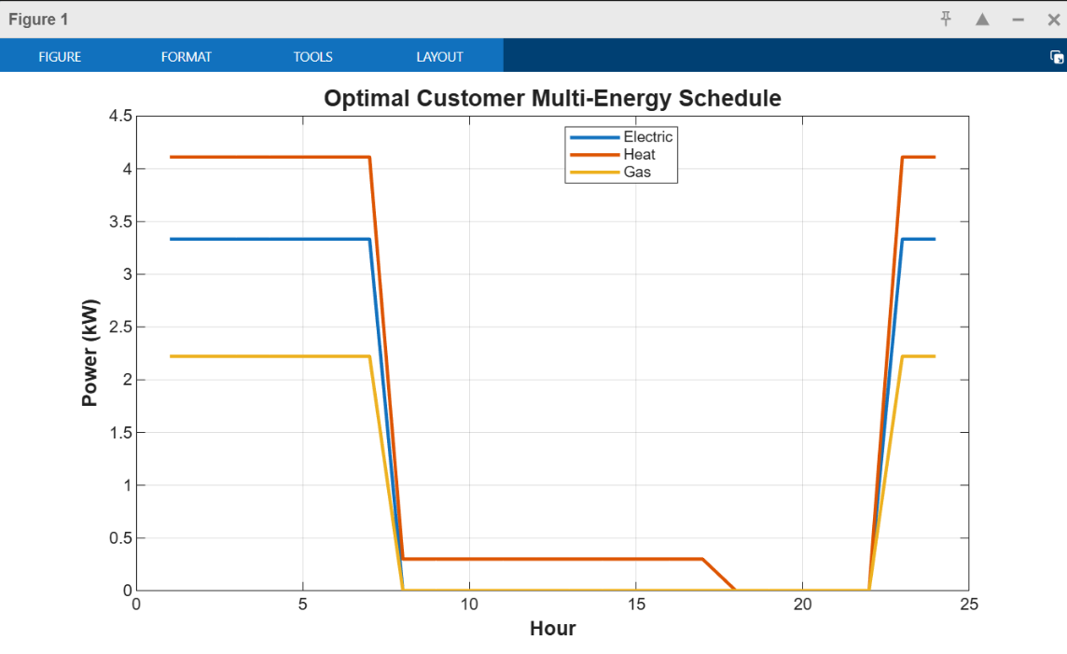
Figure 3. Optimal 24-hour schedule of electric, heat and gas demand for the flexible customer in Task 3.
The evolution of the three-phase voltage unbalance index at the customer bus is plotted in Figure 4. The index remains on the order of 1.23×10⁻³ p.u. throughout the day, which is significantly below typical planning limits such as 2%-3% voltage unbalance factor used in distribution codes. The profile exhibits three regimes. In the early hours, although the absolute load is high, the combination of base feeder loading and fixed phase-weighting results in a nearly constant unbalance index. During the intermediate hours with reduced flexible loads, the relative influence of phase asymmetry becomes slightly stronger, producing a small increase in the index to around 1.236×10⁻³. After the evening peak, as the loads ramp up again, the unbalance index decreases slightly because the incremental phase currents help rebalance voltage drops along the three conductors.
Table 3. Key parameters and results of the IDR-OPF (Task 3).
Quantity | Value | Comment
Daily electric energy requirement | 30 kWh | Constraint enforced over 24 h
Daily heat energy requirement | 40 kWh | Constraint enforced over 24 h
Daily gas energy requirement | 20 kWh | Constraint enforced over 24 h
Electric power limit | 40 kW | Per-hour upper bound
Heat power limit | 50 kW | Per-hour upper bound
Gas power limit | 30 kW | Per-hour upper bound
Voltage bounds | 0.95–1.05 p.u. | All phases at customer bus, all hours
Minimum UI | ≈1.233×10⁻³ p.u. | Early-morning and late-evening hours
Maximum UI | ≈1.236×10⁻³ p.u. | Mid-day hours
Final objective value | 6.58×10⁻³ | Energy cost plus unbalance penalty

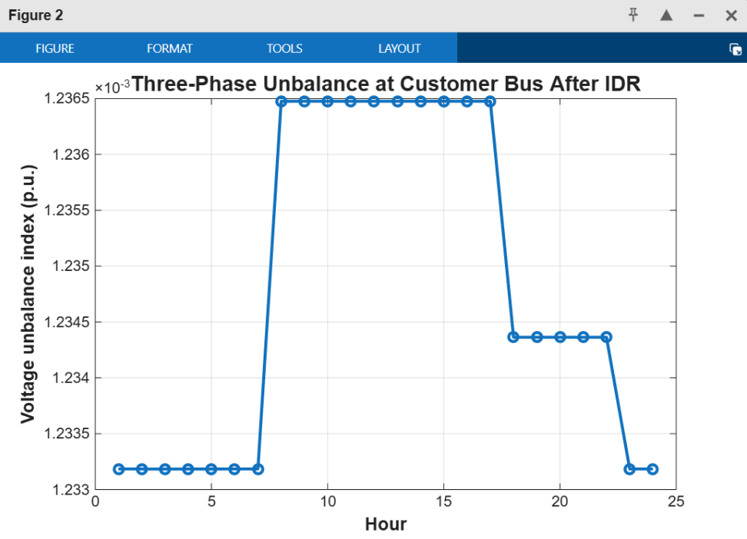
Figure 4. Voltage unbalance index at the customer bus over the 24-hour horizon after optimal IDR scheduling.
The very low time change in the unbalance index indicates the optimisation has achieved avoidance of schedules that take any of the phases too near voltage limits, although the loads have changed greatly with time. This validates the hypothesis that multi-energy IDR can be implemented at the end of unbalanced feeders without impacting the quality of power in the network as long as network-aware constraints and penalties are added to the formulation of the scheduling.

4. Discussion
The three activities that are taken into consideration in the present research create a logical row of models, starting with a comprehensive feeder physics model, then moving to a lumped multi-energy hub model to finally client-level IDR. The findings of the Task 1 prove that the linearised DistFlow models will always be an effective tool in the estimation of the voltage profiles in the radial feeders with a small loading and unbalance. Table 1 shows that the RMSE and worst-case error give results that are consistent with the recent studies that confirm LinDistFlow approximations of full AC power flow in planning and OPF uses [6] [7]. Nevertheless, the apparent inaccuracy of the magnitude of voltage in the middle section of the feeder in Figure 1 is a message to practitioners that such models cannot be applied blindly to protection studies or power-quality analysis.
In Task 2, border-equivalent model illustrates the role of the internal flexibility of multi-energy hubs being succinctly characterised to be coordinated with ADNs and local flexibility markets. The feasible region in Figure 2 indicates the import/export range as well as the degree to which excess heat is obtained in extreme modes of CHP dominance. The bidding curve illustrates how the world can only rationally export electricity aggressively at high prices or when there is some scarcity in the system. This is consistent with recent studies which focus on the contribution of multi-energy hubs as a malleable yet low-cost component of decarbonised energy systems [1].
Task 3 The IDR-OPF formulation builds on previous research of DR in the distribution network focusing more explicitly on three-phase unbalance and incorporates the complete AC power-flow model into the optimisation loop. Such formulations are not computationally light as compared to purely linear formulations, but the small size of the feeder and the single flexible customer in the present case make convergence in a few seconds possible, indicating that larger network sizes can be scaled by analogous methods with effective implementations. The optimal schedules in Figure 3 are economically intuitive and compliant with the best practice in TOU-based DR design at present [8]. Simultaneously, the low and narrow unbalance indices in Figure 4 suggest that network-sensitive punishments are successful in maintaining power quality to offset more conventional control strategies like the method of fixed phase balancing and on-load tap-changer coordination [5].

5. Conclusion and Future Work
The current paper has demonstrated a combined modelling and optimisation framework of unbalanced three-phase distribution networks of multi-energy components and flexible customers. On a test bed of modified IEEE 37-bus feeder, the study benchmarked a Wang-style linear DistFlow approximation against complete three-phase AC power flow and reduced RMSE errors of about 1.1% and also to reveal where linearisation errors are greater. This was followed by development of a border-equivalent model of a local multi-energy hub, which indicates the existence of a feasible region that covers large import and export opportunities and an aggregate bidding curve increasing monotonically with net export. Lastly, the IDR-OPF problem of a single flexible customer was addressed to generate economically sensible electric, heat and gas schedules when subjected to TOU tariffs and maintaining the index of unbalance of voltages at the feeder tail to less than 1.3x10⁻³ p.u. at all hours.
Subsequent research can build on the IDR-OPF model by taking a number of flexible customers at various buses and delve into the overall impact of coordinated DR on feeder losses, hosting capacity and phase-balancing, and include stochastic renewable generation and uncertainty in customer behaviour. The concept of network-constrained market clearing algorithms could be applied in conjunction with the border-equivalent multi-energy hub as well to explore the ways in which the ADN operators can buy flexibilities with the hubs and reacting customers within the same framework.

References
- Zubo RHA, Onen PS, Mujtaba IM, Mokryani G, Abd-Alhameed R. Optimal Scheduling of a Multi-Energy Hub with Integrated Demand Response Programs. Processes [Internet]. 2025 Sep 9 [cited 2025 Nov 23];13(9):2879. Available from: https://www.researchgate.net/publication/395445715_Optimal_Scheduling_of_a_Multi-Energy_Hub_with_Integrated_Demand_Response_Programs
- Kharrazi A. Assessment of Voltage Unbalance Due to single phase Rooftop Photovoltaic Panels in Residential Low Voltage Distribution Network. Australasian Universities Power Engineering Conference 2017 (AUPEC2017) [Internet]. 2017 Nov 30; Available from: https://www.researchgate.net/publication/321375513_Assessment_of_Voltage_Unbalance_Due_to_single_phase_Rooftop_Photovoltaic_Panels_in_Residential_Low_Voltage_Distribution_Network
- E. Demi̇rok, S. Kjær, Sera D, Teodorescu R. Three-Phase Unbalanced Load Flow Tool for Distribution Networks [Internet]. ; 2017 [cited 2025 Nov 23]. Available from: https://www.semanticscholar.org/paper/Three-Phase-Unbalanced-Load-Flow-Tool-for-Networks-Demi%CC%87rok-Kj%C3%A6r/075fe4845ce51b2b7b3b75dd46990eb94a49b8b0
- Faria P, Vale Z. Demand response in electrical energy supply: An optimal real time pricing approach. Energy. 2011 Aug;36(8):5374–84.
- Bajo CG, Hashemi S, Soren Bakkoj Kjsar, Yang G, Ostergaard J. Voltage unbalance mitigation in LV networks using three-phase PV systems. 2015 Mar 1 [cited 2025 Nov 23];2875–9. Available from: https://www.semanticscholar.org/paper/Voltage-unbalance-mitigation-in-LV-networks-using-Bajo-Hashemi/7c1e05ec117569581c5cf12b984501b5bd305654
- Huang J, Cui B, Zhou X, Bernstein A. A Generalized LinDistFlow Model for Power Flow Analysis [Internet]. 2021. Available from: https://www.researchgate.net/publication/350674059_A_Generalized_LinDistFlow_Model_for_Power_Flow_Analysis
- Mendoza Osorio D, Rosero Garcia J. Optimization of Distributed Energy Resources in Distribution Networks: Applications of Convex Optimal Power Flow Formulations in Distribution Networks. Hampannavar S, editor. International Transactions on Electrical Energy Systems [Internet]. 2023 Apr 15 [cited 2025 Nov 23];2023:1–16. Available from: https://www.researchgate.net/publication/370053965_Optimization_of_Distributed_Energy_Resources_in_Distribution_Networks_Applications_of_Convex_Optimal_Power_Flow_Formulations_in_Distribution_Networks
- Haider HT, See OH, W. Elmenreich. Optimal residential load scheduling based on time varying pricing scheme. 2015 Dec 1 [cited 2025 Nov 23];210–4. Available from: https://www.researchgate.net/publication/293131394_Optimal_residential_load_scheduling_based_on_time_varying_pricing_scheme
- Mohammadi M, Younes Noorollahi, Behnam Mohammadi-ivatloo, Hosseinzadeh M, Yousefi H, Sasan Torabzadeh Khorasani. Optimal management of energy hubs and smart energy hubs – A review. Renewable and Sustainable Energy Reviews [Internet]. 2018 Mar 19 [cited 2025 Nov 23];89:33–50. Available from: https://www.semanticscholar.org/paper/Optimal-management-of-energy-hubs-and-smart-energy-Mohammadi-Noorollahi/0a5d47ef604d247bba8eccac23617e80c8dab9bf
- Alghamdi AS, Mohana Alanazi, Abdulaziz Alanazi, Yazeed Qasaymeh, Zubair M, Awan AB, et al. Energy Hub Optimal Scheduling and Management in the Day-Ahead Market Considering Renewable Energy Sources, CHP, Electric Vehicles, and Storage Systems Using Improved Fick’s Law Algorithm. Applied Sciences [Internet]. 2023 Mar 9 [cited 2025 Nov 23];13(6):3526–6. Available from: https://www.mdpi.com/2076-3417/13/6/3526
‌

